FDNZ presents
‘A Mediterranean Magic Carpet Ride’
Fun dance workshops to warm up your winter -August 8th

TUTOR PROFILES
Jim Lovell-Smith
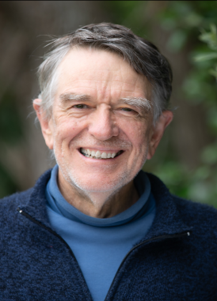
Jim has been dancing with the Farandol Foikdancers in Christchurch for over 20 years. He believes dancing is good for his body, his brain and his psyche.

During the years he was working full time he really appreciated dancing with Farandol on Friday nights as it helped him switch off from the stresses of the week. Over the past few years Jim has sometimes filled in to run evenings when Judy is unavailable, and occasionally teaches/leads dances that he loves.

Jim enjoyed learning dances from Lee Otterholt during his visit last year and is excited about sharing these dances with others in New Zealand.

Murray Birch

Murray teaches & leads Balkan Saturday dance classes for a small group of like-minded friends in Auckland.
He loves many types of dance but has a special passion for Greek dance. During his more recent travels he spent 8 months in Southern Europe & the Balkans & attended hundreds of hours of workshops across the Balkan countries with an emphasis on different regions of Greece.
But just as importantly, he danced with the locals at festivals, village celebrations and local venues. Greek culture including food, wine & music, as well as dance, is a strong influence for him.
Murray loves to share his passion for dance. He’ll bring a varied programme from different regions of Greece.
Maybe you’ll get that winter holiday in the Greek Islands after all!

Jane Luiten
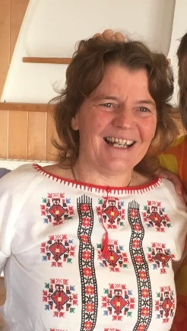 | Jane shares folk dance on a weekly basis in Tūranga Gisborne. Mostly because she enjoys the music, movement, connection and fun that it brings.  Its not often Good Folk gets the numbers for party dance bangers - she is looking forward to trying out old favourites in new clothes with you all.

